PROJECT REPORT

ONLINE AUCTION SYSTEM

CONTRIBUTORS:
MANAS C BAVASKAR: 221080004
AARYA A BODAS: 221080008

ASSIGNMENT 1

ASSIGNMENT 2

ASSIGNMENT 3
a)
Write TRIGGERS on tables for entered data validations, updating derived attributes, updating foreign key data updates, etc. See that how TRIIGERS will help to make correct, non-repeated data entry.

Triggers:
- Unique Buyer and Seller username
TRIGGER CODE:
DELIMITER //
CREATE TRIGGER trg_unique_username
BEFORE INSERT ON Buyers
FOR EACH ROW
BEGIN
DECLARE username_count INT;
SELECT COUNT(*) INTO username_count FROM Buyers WHERE Username = NEW.Username;
IF username_count > 0 THEN
SIGNAL SQLSTATE '45000' SET MESSAGE_TEXT = 'Username already exists in Buyers table';
END IF;
END //

CREATE TRIGGER trg_unique_username_seller
BEFORE INSERT ON Sellers
FOR EACH ROW
BEGIN
DECLARE username_count INT;
SELECT COUNT(*) INTO username_count FROM Sellers WHERE Username = NEW.Username;
IF username_count > 0 THEN
SIGNAL SQLSTATE '45000' SET MESSAGE_TEXT = 'Username already exists in Sellers table';
END IF;
END //
DELIMITER ;

TRIGGER EXPLANATION:
These triggers ensure that a username is unique within the respective tables Buyers and Sellers. Here's what each trigger does:
- Trigger for Buyers Table (trg_unique_username):
  - This trigger is fired before inserting a new row into the Buyers table.
  - It checks if the Username being inserted already exists in the Buyers table.
  - If a record with the same Username already exists, it raises an error using SIGNAL SQLSTATE with a custom error message.
  - This prevents the insertion of a duplicate username into the Buyers table.
- Trigger for Sellers Table (trg_unique_username_seller):
  - This trigger is similar to the previous one but applies to the Sellers table.
  - It is fired before inserting a new row into the Sellers table.
  - It checks if the Username being inserted already exists in the Sellers table.
  - If a record with the same Username already exists, it raises an error using SIGNAL SQLSTATE with a custom error message.
  - This ensures that usernames are unique within the Sellers table.
Here's the test data insertion:
INSERT INTO Buyers (Buyer_ID, Username, Password, Email, Address, Account_Balance) VALUES (99, 'raj_sharma', 'password123', 'raj@example.com', '123 Street', 1000.00);

INSERT INTO Sellers (Seller_ID, Username, Password, Email, Address, Account_Balance) VALUES (99, 'fashion_hub', 'password456', 'fashion@example.com', '456 Avenue', 2000.00);

If we try to insert a duplicate username for either buyers or sellers, the triggers will prevent it and raise an error.
- Set Last_Bid Default Value
TRIGGER CODE:

DELIMITER //

CREATE TRIGGER set_last_bid_default BEFORE INSERT ON items
FOR EACH ROW
BEGIN
IF NEW.Last_bid IS NULL THEN
SET NEW.Last_bid = NEW.Starting_Price;
END IF;
END//

DELIMITER ;

TRIGGER EXPLANATION:
This trigger ensures that when a new row is inserted into the Items table, the Last_bid field is set to the Starting_Price if it's initially NULL. Here's an explanation of the trigger:
Trigger Description:
- Trigger Name: set_last_bid_default
- Event: BEFORE INSERT on the Items table.
- Trigger Type: FOR EACH ROW, meaning it will execute for each row being inserted.
- Action: Sets the Last_bid field to the Starting_Price if Last_bid is initially NULL for the row being inserted.
Explanation:
- IF Statement:
  - Checks if the Last_bid field for the new row being inserted is NULL (IF NEW.Last_bid IS NULL).
- Setting Default Value:
  - If the Last_bid is indeed NULL, it sets the Last_bid field to the Starting_Price for that item (SET NEW.Last_bid = NEW.Starting_Price;).

Purpose:
- This trigger ensures that when a new item is added to the Items table and no previous bids have been made (thus Last_bid is NULL), the Last_bid field is initialized with the Starting_Price of the item. This helps to maintain consistency in the data and ensures that there is always a starting point for bidding on an item.

- Update Last Bid trigger
TRIGGER CODE:
DELIMITER //
CREATE TRIGGER trg_update_last_bid
AFTER INSERT ON Bids
FOR EACH ROW
BEGIN
UPDATE Items
SET Last_Bidder = NEW.Bidder_ID,
Last_Bid = NEW.Bid_Amount
WHERE Item_ID = NEW.Item_ID;
END //
DELIMITER ;

TRIGGER EXPLANATION:
This trigger, named trg_update_last_bid, is designed to update the Last_Bidder and Last_Bid fields in the Items table whenever a new bid is inserted into the Bids table. Here's a breakdown of how it works:
Trigger Description:
- Trigger Name: trg_update_last_bid
- Event: AFTER INSERT on the Bids table.
- Trigger Type: FOR EACH ROW, indicating that the trigger will execute once for each row that is inserted into the Bids table.
- Action: Updates the Last_Bidder and Last_Bid fields in the Items table based on the information of the newly inserted bid.
Explanation:
- UPDATE Statement:
  - The trigger executes an UPDATE statement on the Items table.
  - It sets the Last_Bidder field in the Items table to the Bidder_ID of the newly inserted bid (SET Last_Bidder = NEW.Bidder_ID).
  - It also updates the Last_Bid field in the Items table to the Bid_Amount of the newly inserted bid (SET Last_Bid = NEW.Bid_Amount).
- WHERE Clause:
  - The UPDATE statement applies these changes only to the row in the Items table where the Item_ID matches the Item_ID of the newly inserted bid (WHERE Item_ID = NEW.Item_ID).
Purpose:
- This trigger ensures that whenever a new bid is made on an item (Bids table), the corresponding Last_Bidder and Last_Bid fields in the Items table are updated accordingly. This helps to keep track of the latest bid and the bidder for each item without requiring manual updates.

EXAMPLE:
INSERT INTO Bids (Bid_ID, Bidder_ID, Item_ID, Bid_Amount, Bid_Time, Bid_Status, Bid_Increment) VALUES (123, 1, 19, 200.00, NOW(), 'Active', 0.00);

SELECT Last_Bidder, Last_Bid FROM Items WHERE Item_ID = 19;

After inserting a new bid into the Bids table with Item_ID 19, the trigger will automatically update the Last_Bidder and Last_Bid fields in the Items table. We can then retrieve this updated information using the SELECT statement provided.

- Update Buyer and Seller balance
TRIGGER CODE:
DELIMITER //
CREATE TRIGGER trg_update_buyer_balance
AFTER INSERT ON Transactions
FOR EACH ROW
BEGIN
DECLARE current_balance DECIMAL(10, 2);
SELECT Account_Balance INTO current_balance FROM Buyers WHERE Buyer_ID = NEW.Buyer_ID;

IF current_balance >= NEW.Transaction_Amount THEN
UPDATE Buyers
SET Account_Balance = current_balance - NEW.Transaction_Amount
WHERE Buyer_ID = NEW.Buyer_ID;
ELSE
SIGNAL SQLSTATE '45000' SET MESSAGE_TEXT = 'Insufficient balance for the transaction';
END IF;
END //
DELIMITER ;

DELIMITER //
CREATE TRIGGER trg_update_seller_balance
AFTER INSERT ON Transactions
FOR EACH ROW
BEGIN
UPDATE Sellers
SET Account_Balance = Account_Balance + NEW.Transaction_Amount
WHERE Seller_ID = NEW.Seller_ID;
END //
DELIMITER ;

TRIGGER EXPLANATION:
These two triggers, trg_update_buyer_balance and trg_update_seller_balance, are designed to update the account balances of buyers and sellers respectively after a new transaction is inserted into the Transactions table.
Trigger trg_update_buyer_balance:
- Trigger Name: trg_update_buyer_balance
- Event: AFTER INSERT on the Transactions table.
- Trigger Type: FOR EACH ROW, meaning it executes once for each row that is inserted into the Transactions table.
- Purpose: Update the account balance of the buyer who made the transaction.
Explanation:
- DECLARE Statement:
  - Declares a local variable current_balance of type DECIMAL(10, 2) to store the current account balance of the buyer.
- SELECT Statement:
  - Retrieves the current account balance of the buyer (Account_Balance) from the Buyers table based on the Buyer_ID of the newly inserted transaction (NEW.Buyer_ID).
- IF Statement:
  - Checks if the current balance (current_balance) is sufficient for the transaction amount (NEW.Transaction_Amount).
- UPDATE Statement (IF condition is met):
  - If the current balance is sufficient, it updates the buyer's account balance by subtracting the transaction amount.
- SIGNAL Statement (IF condition is not met):
  - If the current balance is insufficient, it raises an error using SIGNAL SQLSTATE with a custom error message indicating "Insufficient balance for the transaction".
Trigger trg_update_seller_balance:
- Trigger Name: trg_update_seller_balance
- Event: AFTER INSERT on the Transactions table.
- Trigger Type: FOR EACH ROW.
- Purpose: Update the account balance of the seller who made the transaction.
Explanation:
- UPDATE Statement:
  - Updates the account balance of the seller by adding the transaction amount (NEW.Transaction_Amount) to their existing account balance.
Tests:
- After inserting a new transaction into the Transactions table, you can verify the updated account balances of the buyer and seller by querying the Buyers and Sellers tables respectively.

EXAMPLE:
INSERT INTO Transactions (Transaction_ID, Buyer_ID, Seller_ID, Item_ID, Transaction_Amount, Transaction_Time, Payment_Method, Transaction_Status) VALUES (456, 1, 2, 19, 500.00, NOW(), 'Credit Card', 'Success');

SELECT Account_Balance FROM Buyers WHERE Buyer_ID = 1;

SELECT Account_Balance FROM Sellers WHERE Seller_ID = 2;

- Set Winning Bid After Auction Update

TRIGGER CODE:
DELIMITER //
CREATE TRIGGER after_auction_update_set_winning_bid_trigger
AFTER UPDATE ON Auctions
FOR EACH ROW
BEGIN
DECLARE max_bid_id INT;
DECLARE bidder_id INT;
DECLARE winning_bid DECIMAL(10, 2);

IF NEW.Auction_Status = 'Closed' AND OLD.Auction_Status != 'Closed' THEN

-- Selecting the highest bid amount for the item
SELECT MAX(Bid_Amount) INTO winning_bid FROM Bids WHERE Item_ID = NEW.Item_ID;

IF winning_bid IS NOT NULL THEN
-- Selecting the maximum bid ID and incrementing it by 1 for the new bid
SELECT COALESCE(MAX(Bid_ID), 0) + 1 INTO max_bid_id FROM Bids;

-- Selecting the bidder ID associated with the highest bid
SELECT Bidder_ID INTO bidder_id FROM Bids WHERE Item_ID = NEW.Item_ID AND Bid_Amount = winning_bid ORDER BY Bid_Time DESC LIMIT 1;

-- Inserting the winning bid into the Bids table
IF bidder_id IS NOT NULL THEN
INSERT INTO Bids (Bid_ID, Bidder_ID, Item_ID, Bid_Amount, Bid_Time, Bid_Status, Bid_Increment)
VALUES (max_bid_id, bidder_id, NEW.Item_ID, winning_bid, NOW(), 'Winning', 0);
END IF;
END IF;
END IF;
END //
DELIMITER ;

TRIGGER EXPLANATION:
This trigger, named after_auction_update_set_winning_bid_trigger, is designed to automatically set the winning bid for an item in the Bids table after an auction is closed.
Trigger Description:
- Trigger Name: after_auction_update_set_winning_bid_trigger
- Event: AFTER UPDATE on the Auctions table.
- Trigger Type: FOR EACH ROW, meaning it executes once for each row that is updated in the Auctions table.
- Purpose: Automatically sets the winning bid for an item in the Bids table when the corresponding auction is closed.
Explanation:
- IF Statement:
  - Checks if the Auction_Status has changed to 'Closed' (IF NEW.Auction_Status = 'Closed' AND OLD.Auction_Status != 'Closed'), indicating that the auction has been closed.
- Selecting the Winning Bid:
  - If the auction is closed, it selects the highest bid amount (MAX(Bid_Amount)) for the item associated with the closed auction and stores it in the winning_bid variable.
- Handling Winning Bid Existence:
  - If a winning bid exists (winning_bid IS NOT NULL), it proceeds to select the maximum bid ID and increments it by 1 to generate a new bid ID for the winning bid.
  - It then selects the bidder ID associated with the highest bid amount for the item.
- Inserting Winning Bid:
  - If a bidder ID is found (bidder_id IS NOT NULL), it inserts a new row into the Bids table with the generated bid ID, bidder ID, item ID, winning bid amount, current timestamp, 'Winning' status, and zero bid increment.
Test:
- The provided test updates the Auction_Status of a specific auction (Auction_ID = 24) to 'Closed' and then selects the winning bid from the Bids table for the item associated with that auction.

Example:
UPDATE Auctions SET Auction_Status = 'Closed' WHERE Auction_ID = 24;
SELECT * FROM Bids WHERE Item_ID = (SELECT Item_ID FROM Auctions WHERE Auction_ID = 24) AND Bid_Status = 'Winning';

- Insert Transaction on Auction End
TRIGGER CODE:
DELIMITER //
CREATE TRIGGER end_auction_insert_transactions_trigger
BEFORE UPDATE ON Auctions
FOR EACH ROW
BEGIN
DECLARE new_transaction_id INT;

-- Check if the auction end time is in the past or now
IF OLD.Auction_Status != 'Closed' AND NEW.Auction_Status = 'Closed' AND NEW.Auction_End_Time <= NOW() THEN
-- Generate a new transaction ID by incrementing the maximum transaction ID
SET new_transaction_id = (SELECT COALESCE(MAX(Transaction_ID), 0) + 1 FROM Transactions);

-- Fetch the Last_Bidder and Last_Bid from the Items table based on the Item_ID associated with the auction
SET @bidder_username := (SELECT Last_Bidder FROM Items WHERE Item_ID = NEW.Item_ID);
SET @last_bid := (SELECT Last_Bid FROM Items WHERE Item_ID = NEW.Item_ID);

-- Fetch the Buyer_ID using the bidder's username
SET @buyer_id := (SELECT Buyer_ID FROM Buyers WHERE Username = @bidder_username);

-- Insert a new transaction into the Transactions table
INSERT INTO Transactions (Transaction_ID, Buyer_ID, Seller_ID, Item_ID, Transaction_Amount, Transaction_Time, Payment_Method, Transaction_Status)
VALUES (
new_transaction_id, -- New transaction ID
@buyer_id, -- Buyer ID based on Last_Bidder
(SELECT Seller_ID FROM Items WHERE Item_ID = NEW.Item_ID), -- Seller ID from the auction
NEW.Item_ID, -- Item ID from the auction
@last_bid, -- Last bid amount from the auction
NOW(), -- Current timestamp
'Online', -- Payment method (assuming online)
'Completed' -- Transaction status (assuming completed)
);

-- Update the buyer's account balance by subtracting the last bid amount
UPDATE Buyers
SET Account_Balance = Account_Balance - @last_bid
WHERE Buyer_ID = @buyer_id;
END IF;
END //
DELIMITER ;

TRIGGER EXPLANATION:
This trigger, named end_auction_insert_transactions_trigger, is designed to automatically insert a transaction into the Transactions table and update the buyer's account balance when an auction is closed.
Trigger Description:
- Trigger Name: end_auction_insert_transactions_trigger
- Event: BEFORE UPDATE on the Auctions table.
- Trigger Type: FOR EACH ROW, indicating that the trigger will execute once for each row that is updated in the Auctions table.
- Purpose: Automatically inserts a transaction into the Transactions table and updates the buyer's account balance when the auction is closed and its end time has passed.
Explanation:
- IF Statement:
  - Checks if the Auction_Status has changed to 'Closed' (IF OLD.Auction_Status != 'Closed' AND NEW.Auction_Status = 'Closed') and if the Auction_End_Time is less than or equal to the current time (AND NEW.Auction_End_Time <= NOW()), indicating that the auction has ended.
- Generating Transaction ID:
  - Generates a new transaction ID by incrementing the maximum transaction ID found in the Transactions table.
- Fetching Bidder Information:
  - Retrieves the Last_Bidder and Last_Bid from the Items table based on the Item_ID associated with the auction.
- Fetching Buyer ID:
  - Retrieves the Buyer_ID using the bidder's username obtained in the previous step.
- Inserting Transaction:
  - Inserts a new row into the Transactions table with the generated transaction ID, buyer ID, seller ID (obtained from the Items table), item ID, last bid amount, current timestamp, payment method ('Online'), and transaction status ('Completed').
- Updating Buyer's Account Balance:
  - Updates the buyer's account balance by subtracting the last bid amount (@last_bid).
Test:
- The provided test doesn't explicitly show how the trigger works but assumes that an auction with a specific Auction_ID has ended, triggering the update on the Auctions table. The trigger then automatically inserts a transaction into the Transactions table and updates the buyer's account balance.

Example:

UPDATE Auctions
SET Auction_Status = 'Closed'
WHERE Auction_ID = 16

-- Check the latest transaction
SELECT * FROM Transactions ORDER BY Transaction_ID DESC LIMIT 1;

-- Check the buyer's account balance
SELECT * FROM Buyers WHERE Buyer_ID = buyer_id;

After executing this update statement, the trigger will automatically insert a transaction into the Transactions table and update the buyer's account balance if the conditions specified in the trigger are met.

- Update Auction Status
TRIGGER CODE:
DELIMITER $$
CREATE TRIGGER update_auction_status
BEFORE INSERT ON auctions
FOR EACH ROW
BEGIN
IF NEW.Auction_End_Time <= NOW() THEN
SET NEW.Auction_Status = 'Closed';
END IF;
END$$
DELIMITER ;

test
-- Insert a new auction with Auction_End_Time set to a past time
INSERT INTO auctions (Auction_ID, Item_ID, Auction_Start_Time, Auction_End_Time, Auction_Status, Reserve_Price)
VALUES (99, 1, '2024-05-01 12:00:00', '2024-05-15 12:00:00', 'pen', 100.00);

-- Check the inserted auction
SELECT * FROM auctions WHERE Auction_ID = 99;

TRIGGER EXPLANATION:
This trigger, named update_auction_status, is designed to automatically update the Auction_Status field when a new auction is inserted into the auctions table.
Trigger Description:
- Trigger Name: update_auction_status
- Event: BEFORE INSERT on the auctions table.
- Trigger Type: FOR EACH ROW, indicating that the trigger will execute once for each row that is being inserted into the auctions table.
- Purpose: Automatically updates the Auction_Status field to 'Closed' if the Auction_End_Time for the new auction is in the past or equals the current time.
Explanation:
- IF Statement:
  - Checks if the Auction_End_Time for the new auction (NEW.Auction_End_Time) is less than or equal to the current time (NOW()).
- Updating Auction Status:
  - If the Auction_End_Time is indeed in the past or equals the current time, it sets the Auction_Status for the new auction (NEW.Auction_Status) to 'Closed'.
Test:
- The provided test inserts a new auction into the auctions table with an Auction_End_Time that is set to a past time ('2024-05-15 12:00:00'). This should trigger the execution of the trigger, automatically updating the Auction_Status to 'Closed'.

Example:
-- Insert a new auction with Auction_End_Time set to a past time
INSERT INTO auctions (Auction_ID, Item_ID, Auction_Start_Time, Auction_End_Time, Auction_Status, Reserve_Price)
VALUES (99, 1, '2024-05-01 12:00:00', '2024-05-15 12:00:00', 'pen', 100.00);

-- Check the inserted auction
SELECT * FROM auctions WHERE Auction_ID = 99;

After executing this insert statement, the trigger will automatically update the Auction_Status to 'Closed' for the newly inserted auction because its Auction_End_Time is in the past. When you check the inserted auction, you should see the updated Auction_Status reflecting this change.
- Create Bid Entry on Update in items
TRIGGER CODE:
DELIMITER $$
DROP TRIGGER IF EXISTS create_bid_entry_after_update $$
CREATE TRIGGER create_bid_entry_after_update
AFTER UPDATE ON items
FOR EACH ROW
BEGIN
DECLARE bidder_id INT;
DECLARE last_bid DECIMAL(10, 2);
DECLARE bid_increment DECIMAL(10, 2);

SET bidder_id = (SELECT Buyer_ID FROM buyers WHERE Username = NEW.Last_Bidder);

SELECT Last_Bid INTO last_bid FROM items WHERE Item_ID = NEW.Item_ID;

SET bid_increment = GREATEST(NEW.Last_Bid - COALESCE(last_bid, 0), 0);

INSERT INTO bids (Bid_ID, Bidder_ID, Item_ID, Bid_Amount, Bid_Time, Bid_Status, Bid_Increment)
SELECT COALESCE(MAX(Bid_ID), 0) + 1, bidder_id, NEW.Item_ID, NEW.Last_Bid, NOW(), 'Outbid', bid_increment FROM bids;
END$$
DELIMITER ;

TRIGGER EXPLANATION:

This trigger, named create_bid_entry_after_update, is designed to automatically create a new bid entry in the bids table after an update on the items table.
Trigger Description:
- Trigger Name: create_bid_entry_after_update
- Event: AFTER UPDATE on the items table.
- Trigger Type: FOR EACH ROW, indicating that the trigger will execute once for each row that is updated in the items table.
- Purpose: Automatically creates a new bid entry in the bids table when the Last_Bid field of an item is updated.
Explanation:
- Declaration of Variables:
  - Declares three variables: bidder_id to store the ID of the bidder, last_bid to store the last bid amount for the item, and bid_increment to store the difference between the new bid amount and the previous bid amount.
- Fetching Bidder ID:
  - Sets the bidder_id variable by selecting the Buyer_ID from the buyers table based on the username (NEW.Last_Bidder) provided in the updated row.
- Fetching Last Bid:
  - Selects the Last_Bid from the items table based on the Item_ID of the updated row and stores it in the last_bid variable.
- Calculating Bid Increment:
  - Calculates the bid increment by finding the difference between the new bid amount (NEW.Last_Bid) and the previous bid amount (last_bid). It ensures that the bid increment is always non-negative.
- Inserting Bid Entry:
  - Inserts a new row into the bids table with the following values:
    - Bid_ID: The maximum bid ID incremented by 1.
    - Bidder_ID: The ID of the bidder fetched earlier.
    - Item_ID: The Item_ID of the updated row.
    - Bid_Amount: The new bid amount (NEW.Last_Bid).
    - Bid_Time: The current timestamp.
    - Bid_Status: 'Outbid' indicating that the previous bid has been outbid.
    - Bid_Increment: The calculated bid increment.
Test:
- This trigger is automatically executed after an update is performed on the items table. You can simulate this by updating the Last_Bid field of an item in the items table.

Example:
-- Update the Last_Bid field of an item in the items table
UPDATE items SET Last_Bid = 150.00 WHERE Item_ID = 1;

-- This update will trigger the execution of the trigger create_bid_entry_after_update

After executing this update statement, the trigger will automatically create a new bid entry in the bids table based on the updated Last_Bid value for the item with Item_ID 1.

b) Write PROCEDURES to minimize the complexity of AGGREGATE functions used in SQL Query, to create NEW FUNCTIONS for which AGGREGATE function is not available, etc.

PROCEDURES:

- CalculateAverageTransaction: This procedure calculates the average transaction amount for a given seller ID. It takes the seller ID as input and calculates the average transaction amount by querying the Transactions table for transactions made by that seller. The result is then returned.

PROCEDURE CODE:
DELIMITER //

CREATE PROCEDURE CalculateAverageTransaction(IN sellerID INT)
BEGIN
DECLARE avgTransaction DECIMAL(10, 2);

SELECT AVG(Transaction_Amount) INTO avgTransaction
FROM Transactions
WHERE Seller_ID = sellerID;

SELECT avgTransaction;
END //

DELIMITER ;

PROCEDURE EXAMPLE:
CALL CalculateAverageTransaction(1);

- CountBidsForItem: This procedure counts the number of bids for a given item ID. It takes the item ID as input and calculates the count by querying the Bids table for bids made on that item. The result is then returned.

PROCEDURE CODE:
DELIMITER //

CREATE PROCEDURE CountBidsForItem(IN itemID INT)
BEGIN
DECLARE bidCount INT;

SELECT COUNT(*) INTO bidCount
FROM Bids
WHERE Item_ID = itemID;

SELECT bidCount;
END //

DELIMITER ;

PROCEDURE EXAMPLE:
CALL CountBidsForItem(1);

- FindMaxBidAmountForItem: This function finds the maximum bid amount for a given item ID. It takes the item ID as input and calculates the maximum bid amount by querying the Bids table for bids made on that item. The maximum bid amount is then returned.

PROCEDURE CODE:
DELIMITER //

CREATE FUNCTION FindMaxBidAmountForItem(itemID INT) RETURNS DECIMAL(10, 2)
BEGIN
DECLARE maxBid DECIMAL(10, 2);

SELECT MAX(Bid_Amount) INTO maxBid
FROM Bids
WHERE Item_ID = itemID;

RETURN maxBid;
END //

DELIMITER ;

PROCEDURE EXAMPLE:
SELECT FindMaxBidAmountForItem(1);

- CalculateTotalSalesAmount: This procedure calculates the total sales amount for a given seller ID. It takes the seller ID as input and calculates the total sales amount by querying the Transactions table for transactions made by that seller. The result is then returned.

PROCEDURE CODE:
DELIMITER //

CREATE PROCEDURE CalculateTotalSalesAmount(IN sellerID INT)
BEGIN
DECLARE totalSales DECIMAL(10, 2);

SELECT SUM(Transaction_Amount) INTO totalSales
FROM Transactions
WHERE Seller_ID = sellerID;

SELECT totalSales;
END //

DELIMITER ;

PROCEDURE EXAMPLE:
CALL CalculateTotalSalesAmount(1);

- CalculateAverageAuctionDuration: This procedure calculates the average duration of auctions in a given category. It takes the category as input and calculates the average duration by querying the Auctions and Items tables, joining them on the Item_ID, and filtering by the specified category. The duration of each auction is calculated using the difference between the auction start and end times. The average duration is then returned.

PROCEDURE CODE:
DELIMITER //

DROP PROCEDURE IF EXISTS CalculateAverageAuctionDuration;
DELIMITER //

CREATE PROCEDURE CalculateAverageAuctionDuration(IN category VARCHAR(50))
BEGIN
DECLARE avgDuration DECIMAL(10, 2);

SELECT AVG(TIMESTAMPDIFF(SECOND, Auctions.Auction_Start_Time, Auctions.Auction_End_Time)) INTO avgDuration
FROM Auctions
INNER JOIN Items ON Auctions.Item_ID = Items.Item_ID
WHERE Items.Category = category;

SELECT avgDuration;
END //

DELIMITER ;

PROCEDURE EXAMPLE:
CALL CalculateAverageAuctionDuration('Electronics');

- CountItemsSoldByBuyer: This function counts the number of items sold by a given buyer ID. It takes the buyer ID as input and calculates the count by querying the Transactions table for transactions where the specified buyer is the buyer. The count is then returned.

PROCEDURE CODE:

DELIMITER //

CREATE FUNCTION CountItemsSoldByBuyer(buyerID INT) RETURNS INT
BEGIN
DECLARE itemCount INT;

SELECT COUNT(*) INTO itemCount
FROM Transactions
WHERE Buyer_ID = buyerID;

RETURN itemCount;
END //

DELIMITER ;

PROCEDURE EXAMPLE:
SELECT CountItemsSoldByBuyer(1);
Declare which part of the database has triggers and procedures defined:

In most modern database systems, the Information Schema contains views related to triggers, providing insights into their definitions and associated objects. Commonly, these views include:
- Triggers View: This view typically contains metadata about triggers defined in the database, including their names, associated tables, events, and actions.
- Trigger Columns View: Some systems offer this view to provide details about the columns affected by each trigger.
Procedures in the Information Schema:
Similar to triggers, procedures also have their metadata exposed through the Information Schema, facilitating querying and analysis. Relevant views may include:
- Routines View: This view usually lists all routines (including procedures and functions) defined in the database, along with their names, types, and other attributes.
- Routine Parameters View: If procedures accept parameters, this view provides information about the parameters, such as names, data types, and positions.

TO VIEW ALL TRIGGERS:
SELECT
TRIGGER_NAME,
EVENT_OBJECT_TABLE
FROM
INFORMATION_SCHEMA.TRIGGERS;

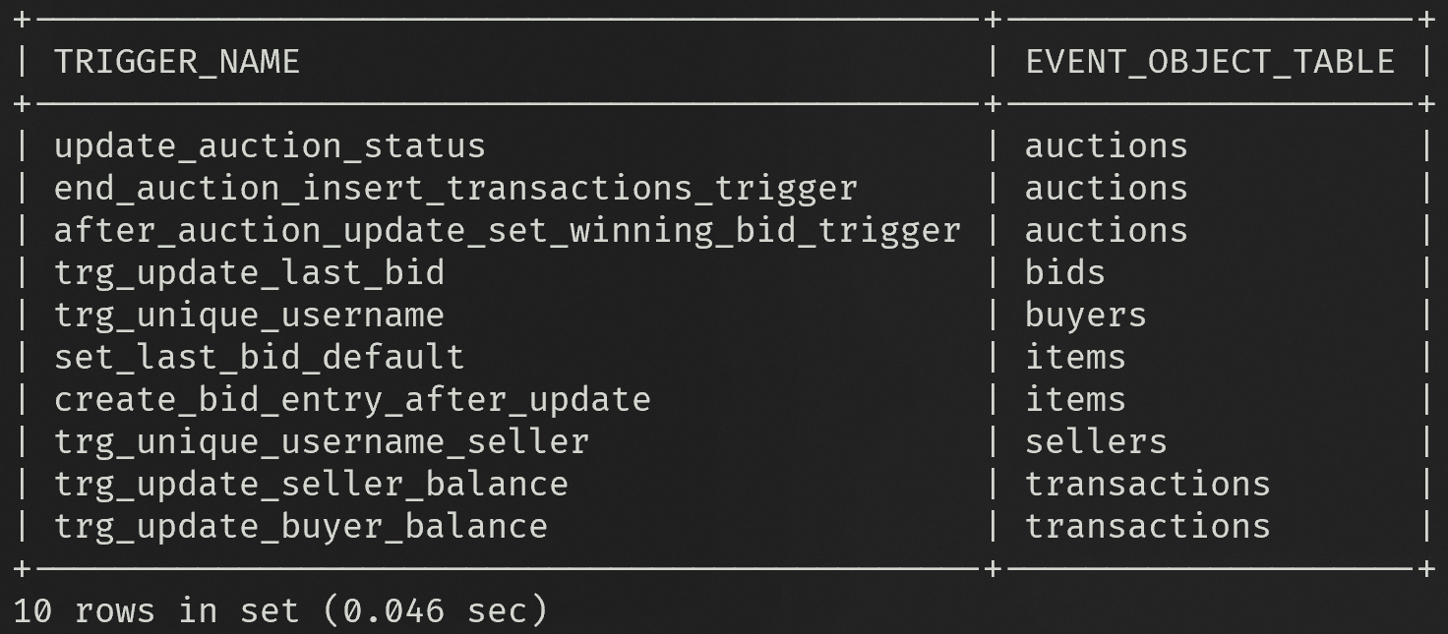

TO VIEW ALL PROCEDURES:
SELECT
ROUTINE_SCHEMA,
ROUTINE_NAME
FROM INFORMATION_SCHEMA.ROUTINES
WHERE ROUTINE_TYPE = 'PROCEDURE';

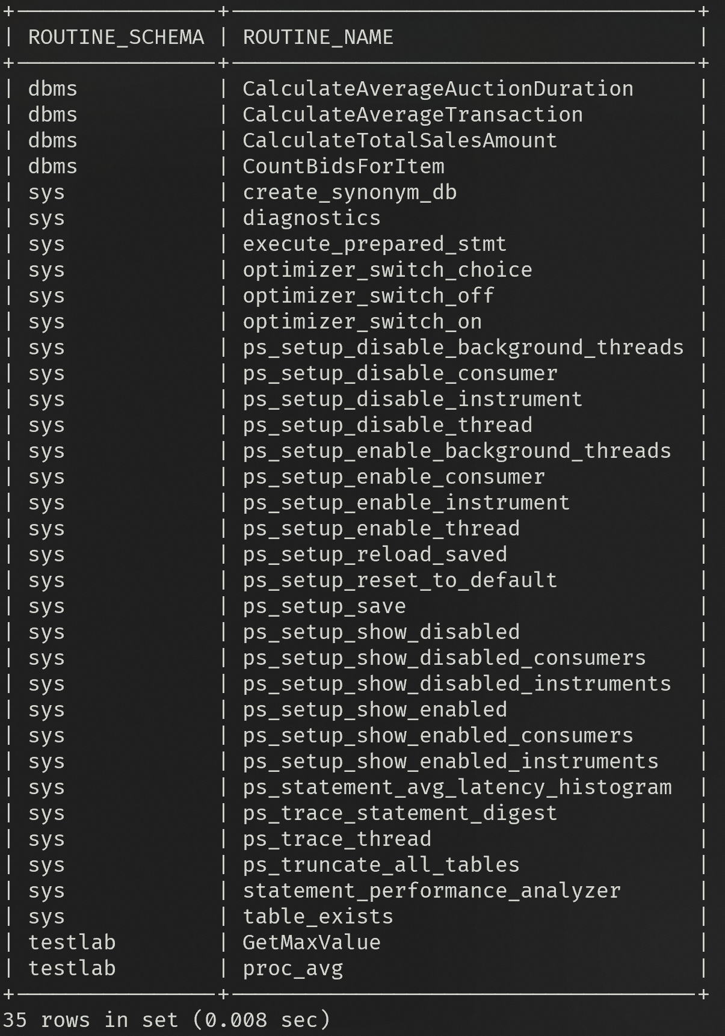
Explain the Data Dictionary details for Triggers and Procedures.
Triggers and procedures are defined within the schema of the online auction system database. Triggers are defined to enforce data integrity, handle automatic updates, and perform certain actions upon specific events in the database tables. Procedures are defined to encapsulate reusable logic for performing calculations or data analysis within the database.
Specifically, the triggers are defined for the following tables:
- Buyers
- Sellers
- Items
- Bids
- Auctions
- Transactions
The procedures are defined to perform various calculations and data analysis tasks within the database, such as calculating averages, counting bids, finding maximum bid amounts, and calculating total sales amounts.

Triggers:
- trg_unique_username:
  - Description: Ensures uniqueness of usernames in the Buyers table.
  - Event: BEFORE INSERT ON Buyers
  - Action: Checks if the inserted username already exists in the Buyers table and signals an error if it does.
- trg_unique_username_seller:
  - Description: Ensures uniqueness of usernames in the Sellers table.
  - Event: BEFORE INSERT ON Sellers
  - Action: Checks if the inserted username already exists in the Sellers table and signals an error if it does.
- set_last_bid_default:
  - Description: Sets the Last_Bid field to the Starting_Price if it is null when inserting into the Items table.
  - Event: BEFORE INSERT ON Items
  - Action: If the Last_Bid field is null, it sets it to the Starting_Price.
- trg_update_last_bid:
  - Description: Updates the Last_Bidder and Last_Bid fields in the Items table after a bid is inserted.
  - Event: AFTER INSERT ON Bids
  - Action: Updates the Last_Bidder and Last_Bid fields in the Items table based on the inserted bid.
- trg_update_buyer_balance:
  - Description: Updates the Account_Balance of the buyer after a transaction is inserted, checking for sufficient balance.
  - Event: AFTER INSERT ON Transactions
  - Action: Checks if the buyer has sufficient balance for the transaction and updates the Account_Balance accordingly.
- trg_update_seller_balance:
  - Description: Updates the Account_Balance of the seller after a transaction is inserted.
  - Event: AFTER INSERT ON Transactions
  - Action: Updates the Account_Balance of the seller based on the inserted transaction.
- after_auction_update_set_winning_bid_trigger:
  - Description: Sets the winning bid for an item after an auction is closed.
  - Event: AFTER UPDATE ON Auctions
  - Action: Sets the winning bid for an item if the auction status is changed to 'Closed'.
- end_auction_insert_transactions_trigger:
  - Description: Inserts a transaction after an auction ends.
  - Event: BEFORE UPDATE ON Auctions
  - Action: Inserts a transaction and updates buyer's account balance after an auction ends.
- update_auction_status:
  - Description: Updates the Auction_Status to 'Closed' if the Auction_End_Time is in the past when inserting into the Auctions table.
  - Event: BEFORE INSERT ON Auctions
  - Action: Sets the Auction_Status to 'Closed' if the Auction_End_Time is in the past.
- create_bid_entry_after_update:
- Description: Inserts a bid entry after an item's Last_Bid is updated.
- Event: AFTER UPDATE ON Items
- Action: Inserts a bid entry with the updated Last_Bid value.
Procedures:
- CalculateAverageTransaction:
  - Description: Calculates the average transaction amount for a given seller.
  - Parameters: sellerID (INT)
  - Returns: avgTransaction (DECIMAL)
- CountBidsForItem:
  - Description: Counts the number of bids for a given item.
  - Parameters: itemID (INT)
  - Returns: bidCount (INT)
- FindMaxBidAmountForItem:
  - Description: Finds the maximum bid amount for a given item.
  - Parameters: itemID (INT)
  - Returns: maxBid (DECIMAL)
- CalculateTotalSalesAmount:
  - Description: Calculates the total sales amount for a given seller.
  - Parameters: sellerID (INT)
  - Returns: totalSales (DECIMAL)
- CalculateAverageAuctionDuration:
  - Description: Calculates the average duration of auctions for a given category.
  - Parameters: category (VARCHAR)
  - Returns: avgDuration (DECIMAL)
- CountItemsSoldByBuyer:
  - Description: Counts the number of items sold by a given buyer.
  - Parameters: buyerID (INT)
  - Returns: itemCount (INT)

Write the SQL Queries for fetching/processing triggers and procedures details.

Fetch Triggers Details:
-- Fetch all triggers in the database
SHOW TRIGGERS;

-- Fetch details of a specific trigger
SHOW CREATE TRIGGER trg_name;

Fetch Procedures Details:
-- Fetch all procedures in the database
SHOW PROCEDURES;

-- Fetch details of a specific procedure
SHOW CREATE PROCEDURE proc_name;
ASSIGNMENT 4
BUYER PORTAL
Login Page:
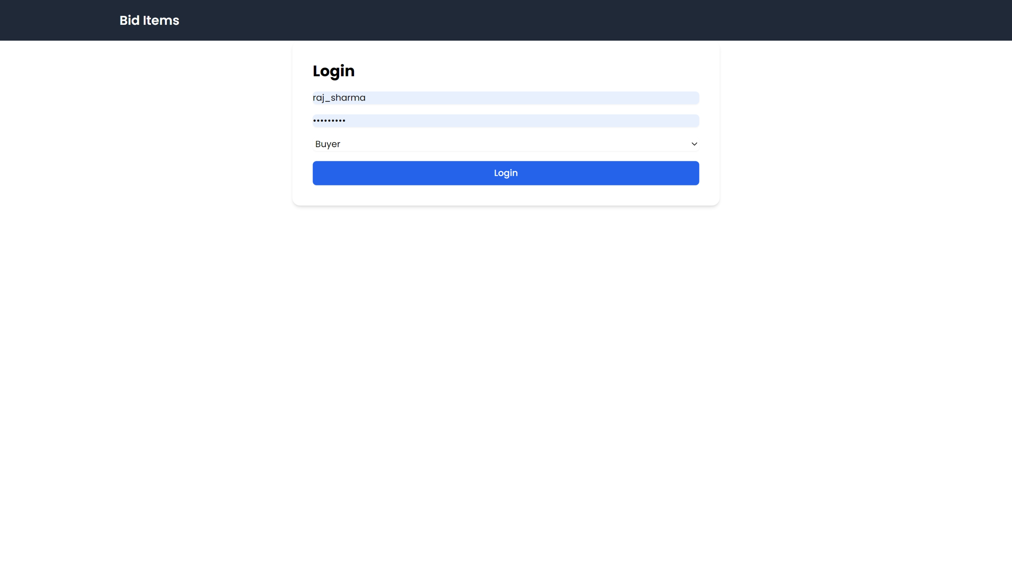
View Products Page:
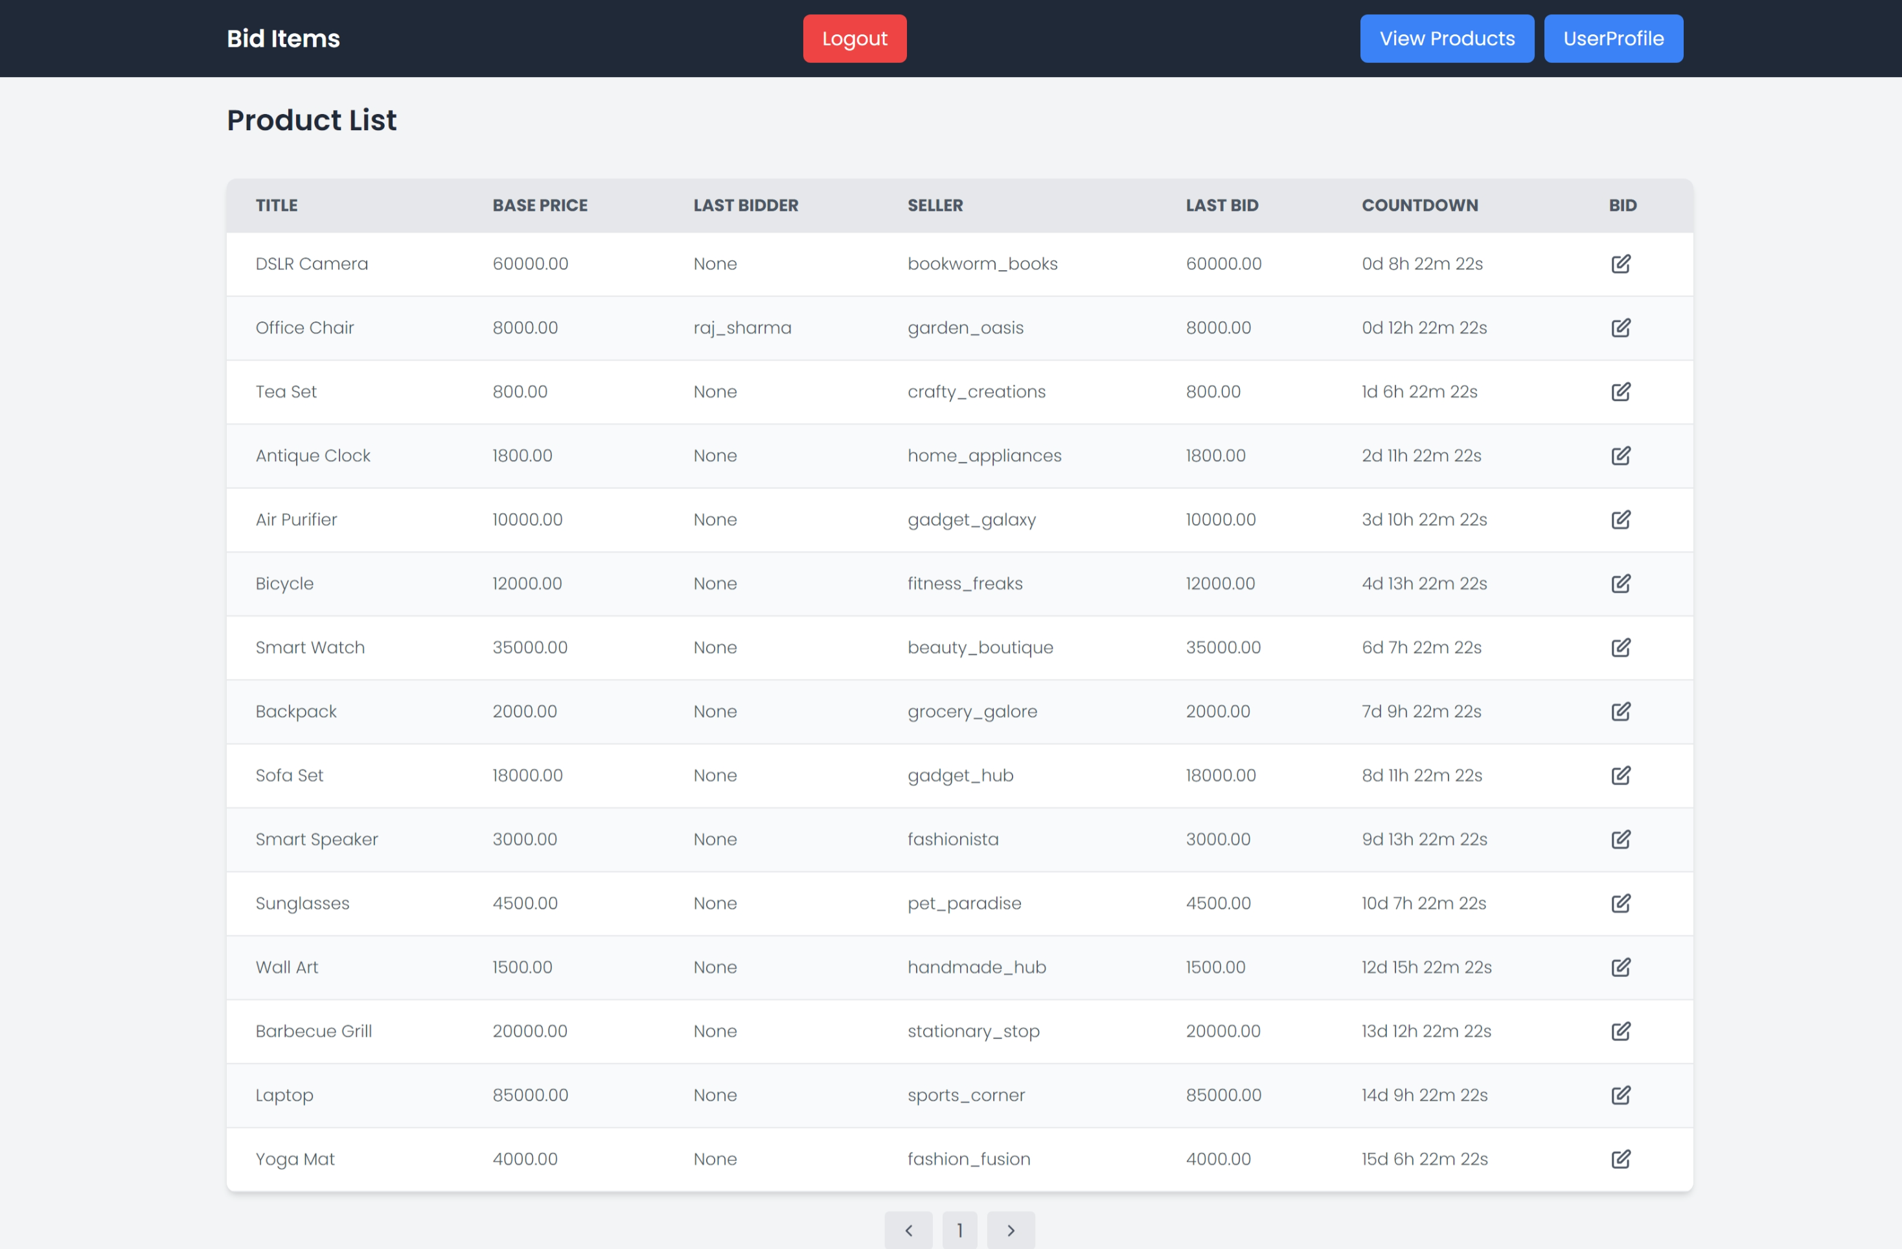
Bid on Product Page:
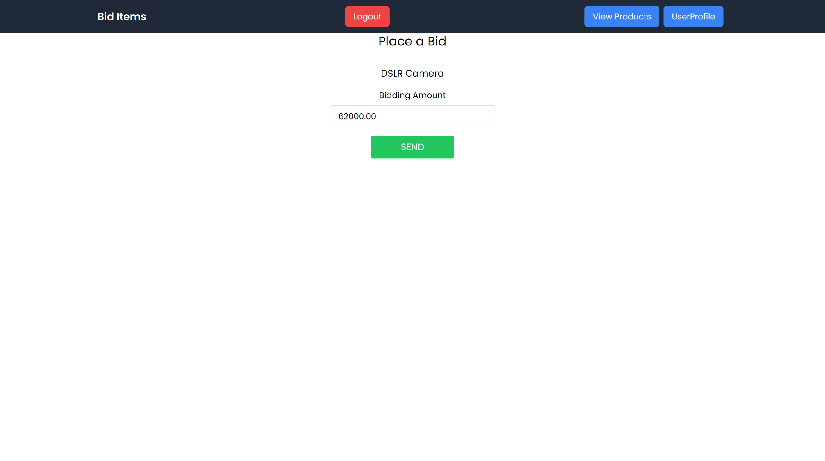

User Profile Page:
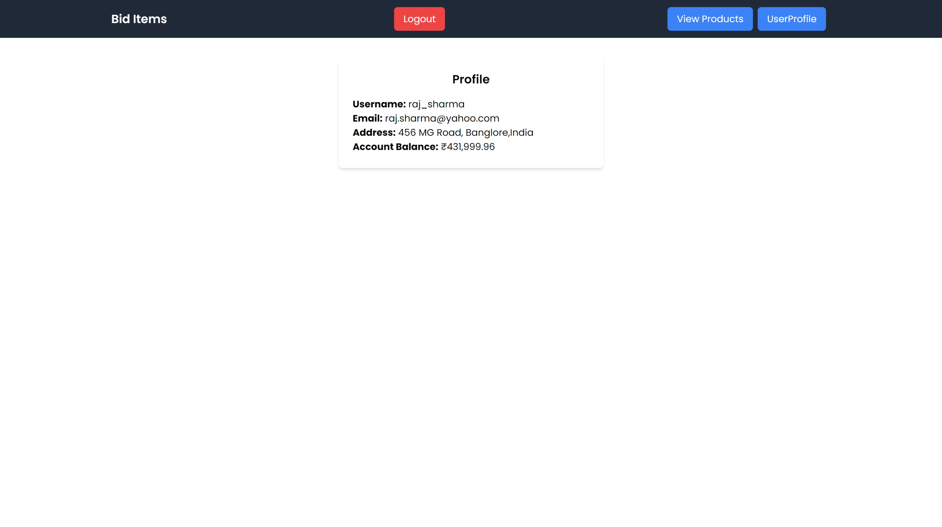

SELLER PORTAL

SELLER DASHBOARD PAGE:
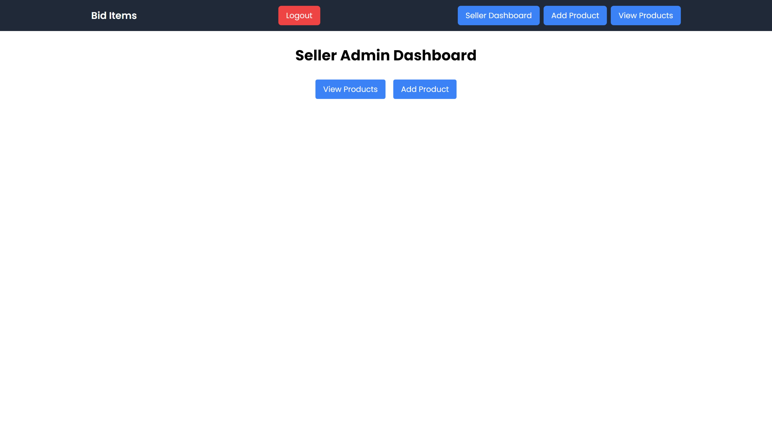

PRODUCTS LISTED BY SELLER PAGE:
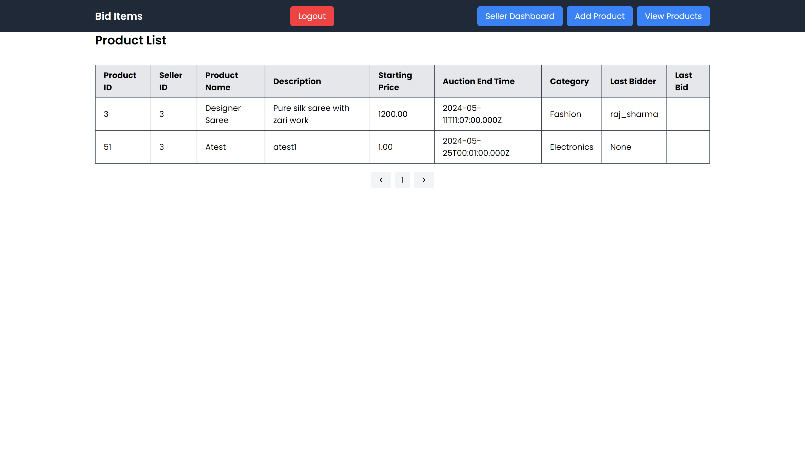

LIST NEW PRODUCT PAGE:
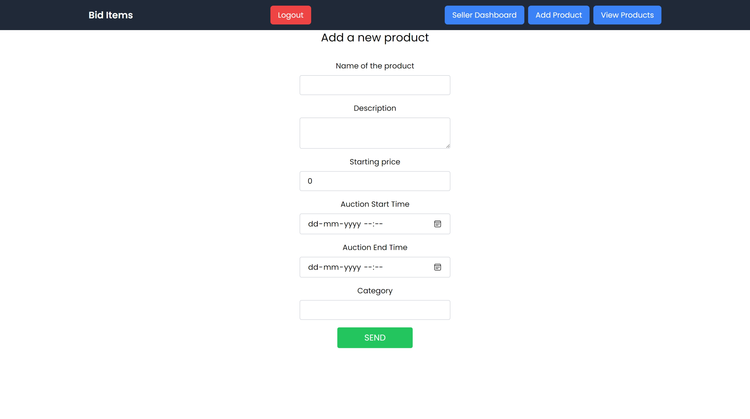

ADMIN PORTAL

ADMIN DASHBOARD PAGE:
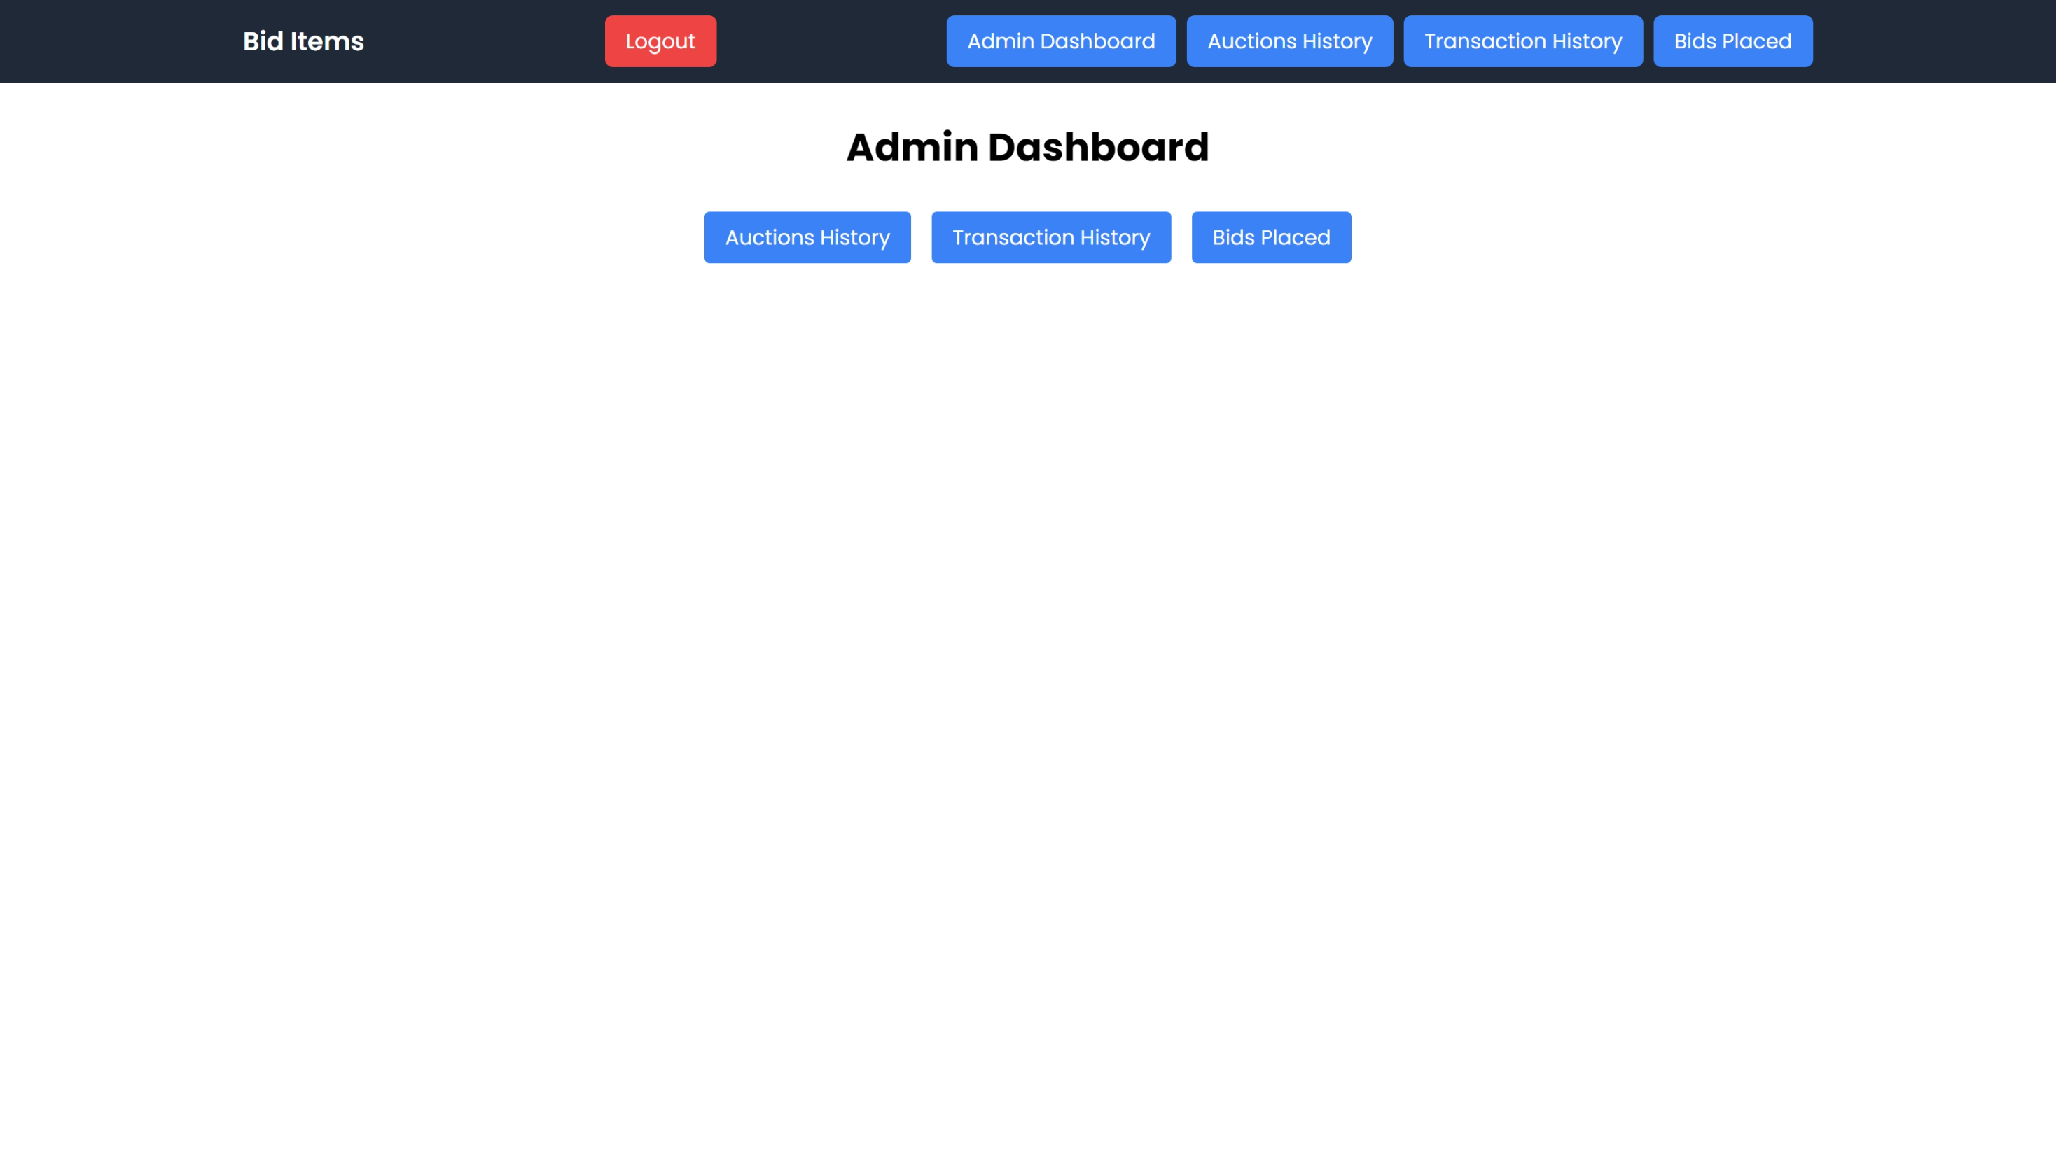

AUCTIONS HISTORY PAGE:
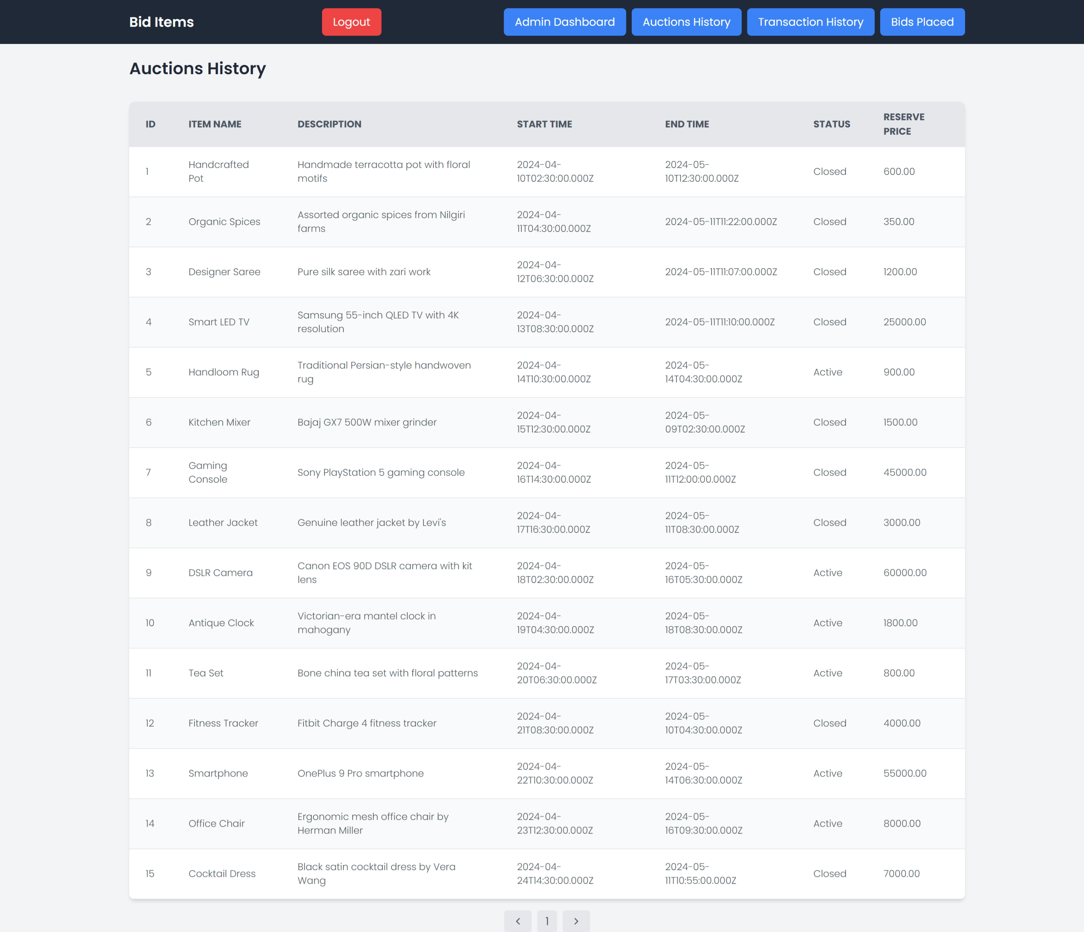

TRANSACTIONS HISTORY PAGE:
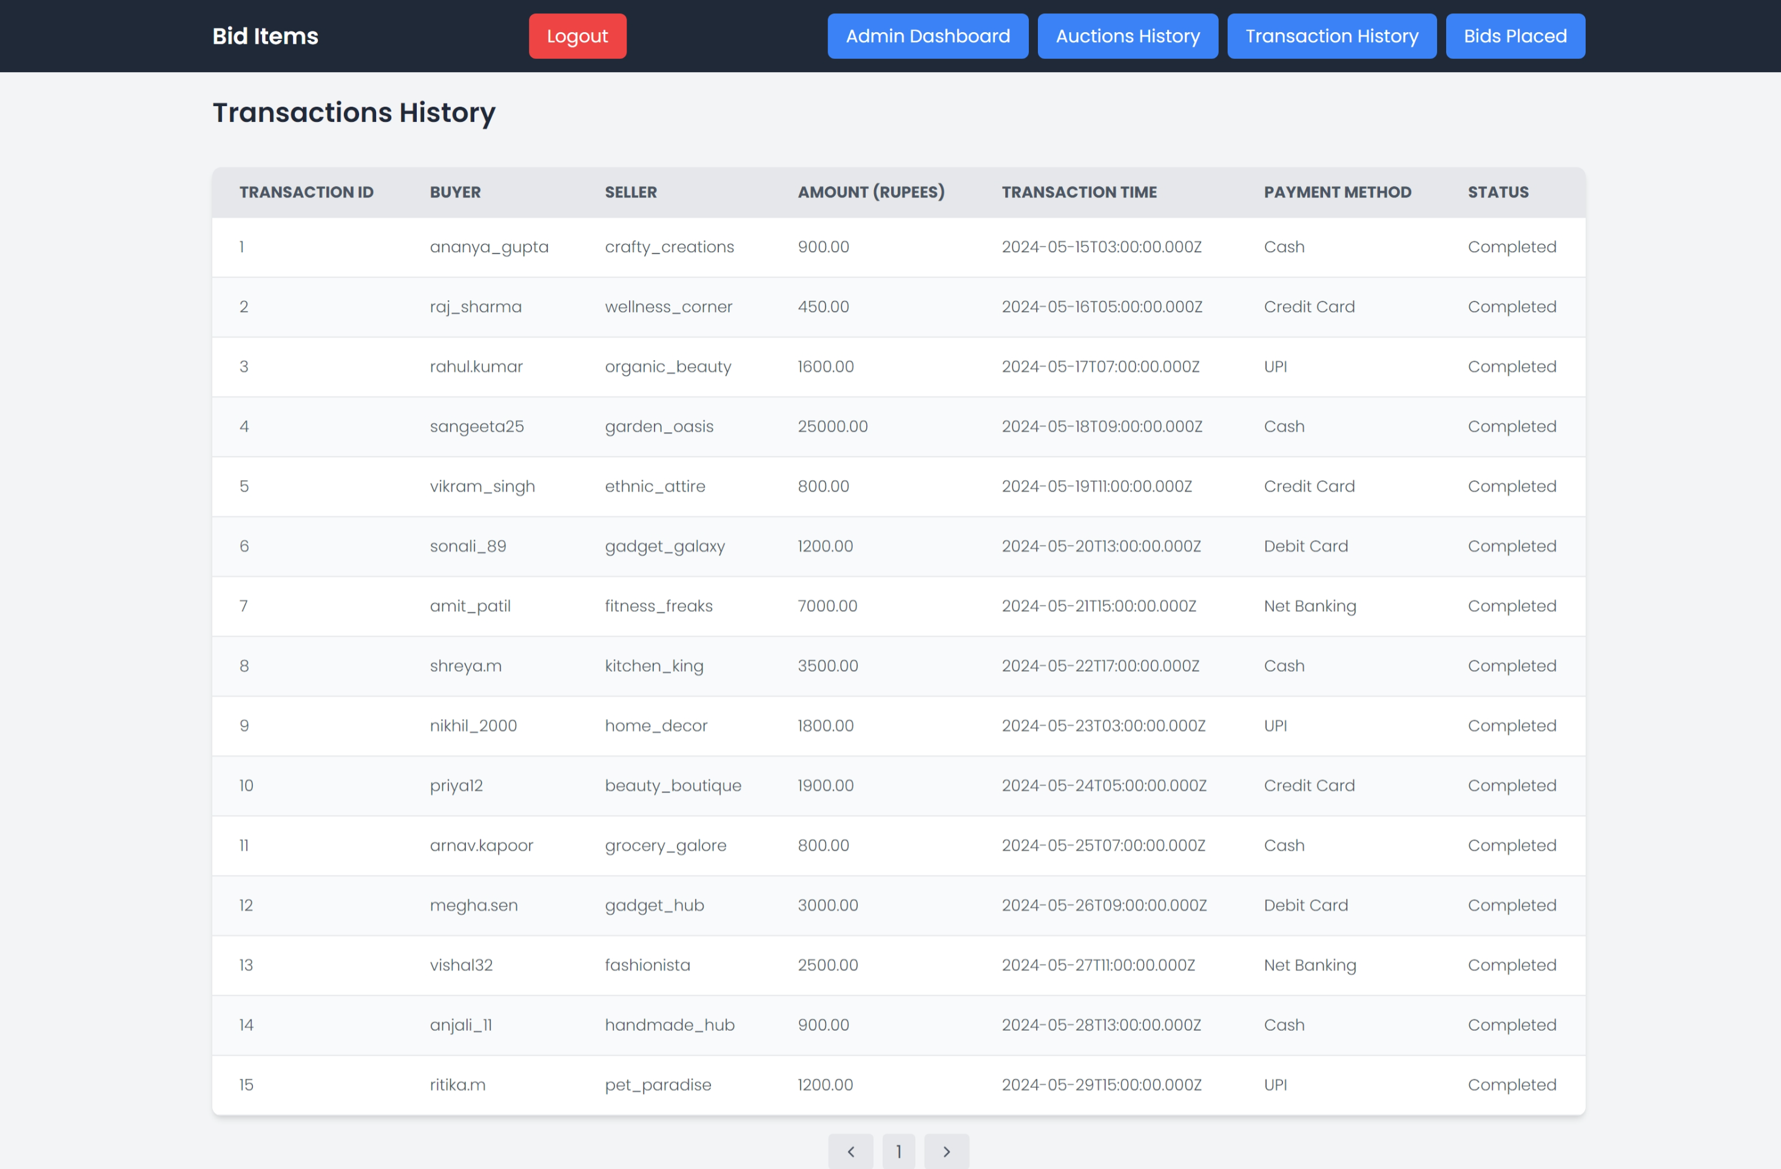

BIDS PLACED PAGE:
